**ERD Model PART 3**

Illustrate that you understand normalization and how to use it to reduce uncontrolled redundancy in your database design by creating two ERD diagrams:

**Answer:** Normalization has been used in this database system in order to decline the redundancy of data values. It has effectively applied to give structure to the different data values and eliminate the duplicate values whenever found in the dataset. Subsequently, a large dataset can be divided into smaller tables that sequentially helped an analyst to develop an ERD diagram.

Create the first using UML and the Umlet free utility.

**Answer:**

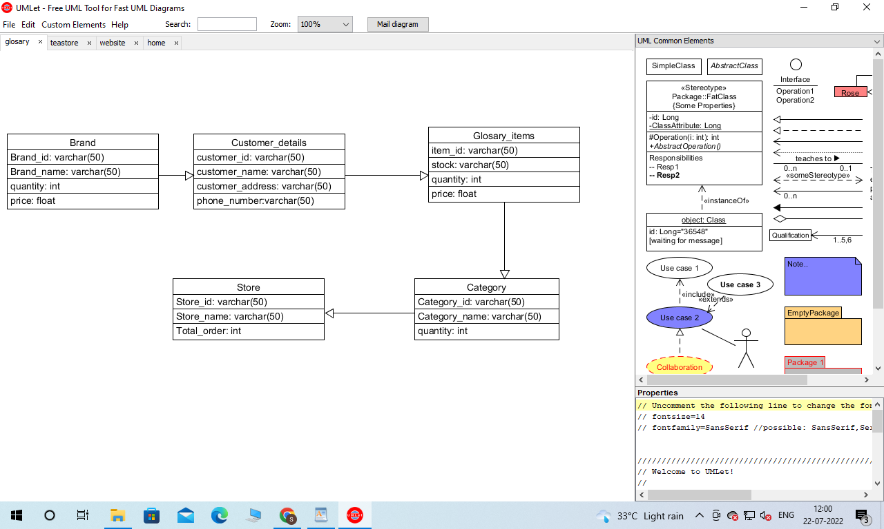

Create the second using Crow’s Foot notation in Vertabelo.

**Answer:**

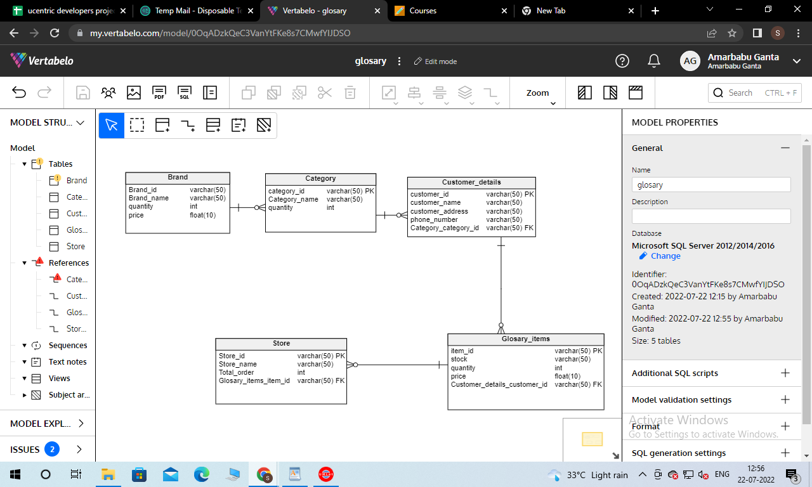

Upload both drawings to **GitHub**. The ERDs must both be **physical** models (includes data types and key information).

10 points for each physical model in GitHub for a total of 20 points.

See the help files in Blackboard, Week 3 for help using Umlet and Vertabelo.